A1502-MEX- Teotihuacan-Incensario Lid –Ceramic-400-700 CE



Fig. 1. Teotihuacan-Incensario Lid –Ceramic-400-700 CE

Case no.: 10

Accession Number: A1502

Formal Label: Teotihuacan-Incensario Lid –Ceramic-400-700 CE

Display Description: This elaborate lid fragment from a ceremonial *incensario* (incense burner) depicts the head of a warrior wearing a large headdress and earplugs. In 500 C.E. Teotihuacan, in central Mexico, was one of the largest cities in the world, with an estimated population of 150,000. Teotihuacan’s culture, religion, and art spread throughout Mexico and Central America. This lid represents the Teotihuacan prototype.

LC Classification:  [F1301](http://librarycatalog.unh.edu/search~S5?/fF1301+.W85/ff++1301+w85/-3,-1,,B/browse)

Date or Time Horizon: 400-700 CE

Geographical Area: Teotihuacan

Map, GPS coordinates: [19°41′33″N 98°50′37.68″W](https://tools.wmflabs.org/geohack/geohack.php?pagename=Teotihuacan&params=19_41_33_N_98_50_37.68_W_type:landmark)

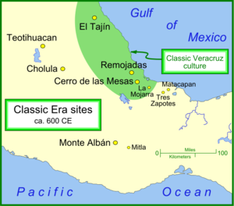

Fig. 2. Map of Teotihuacan and other important Classic Era settlements. From https://upload.wikimedia.org/wikipedia/commons/thumb/b/b9/Classic_sites_1.png/450px-Classic_sites_1.png

Cultural Affiliation: Teotihuacan

Media: ceramic

Dimensions:

Weight:

Condition: original

Provenance: unknown

Discussion:

This lid, found more than seven hundred miles away from Teotihuacan in the Tiquisate Region, Department of Escuintla, Guatemala, represents a local version of the Teotihuacan prototype that is illustrated in our example. The following is the Brooklyn Museum’s description of it:

“Elaborate incensario or incense burner lid in the form of a male bust wearing a spectacular headdress with three discs, two feathered quetzal eyes and three bundles of spear ends. The figure wears large circular ear spools and a removable trapazoidal talud-tablero style nose ornament. He carries a blade-like object in the left hand and a bundle of spear ends in the right, suggesting a warrior figure. White, buff, yellow, ochre and red paint are still visible throughout the piece. Teotihuacan-style incense burners usually consist of two basic sections: an hourglass-shaped base (missing) and an elaborate chimney lid. Incense burners from Escuintla, Guatemala generally have unadorned bases and elaborate lids. The presence of Teotihuacan-style incensarios on Guatemala's Pacific coast (about 700 miles away from the Valley of Mexico), attest to the success of Teotihuacan expansion throughout Central America. The original molds for the decorative elements were probably brought south from Central Mexico, but assembled in a local manner typical of Escuintla.” From https://www.brooklynmuseum.org/opencollection/objects/1542

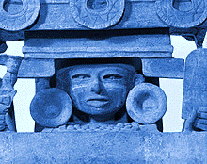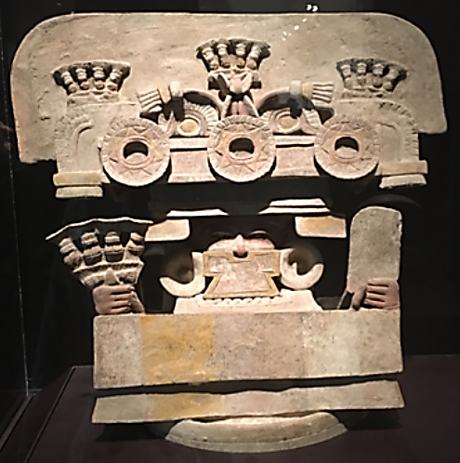

Teotihuacan style. *Incensario Lid*, 400-700 C.E. Ceramic, pigment, 18 1/8 x 19 1/2 x 9 1/4in. (46 x 49.5 x 23.5cm). Brooklyn Museum, Gift of Mr. and Mrs. Richard Danziger, 75.148. Creative Commons-BY (Photo: Brooklyn Museum, 75.148_bw.jpg).

Appendix:

AP.7